OS-6 Data Output Instructions

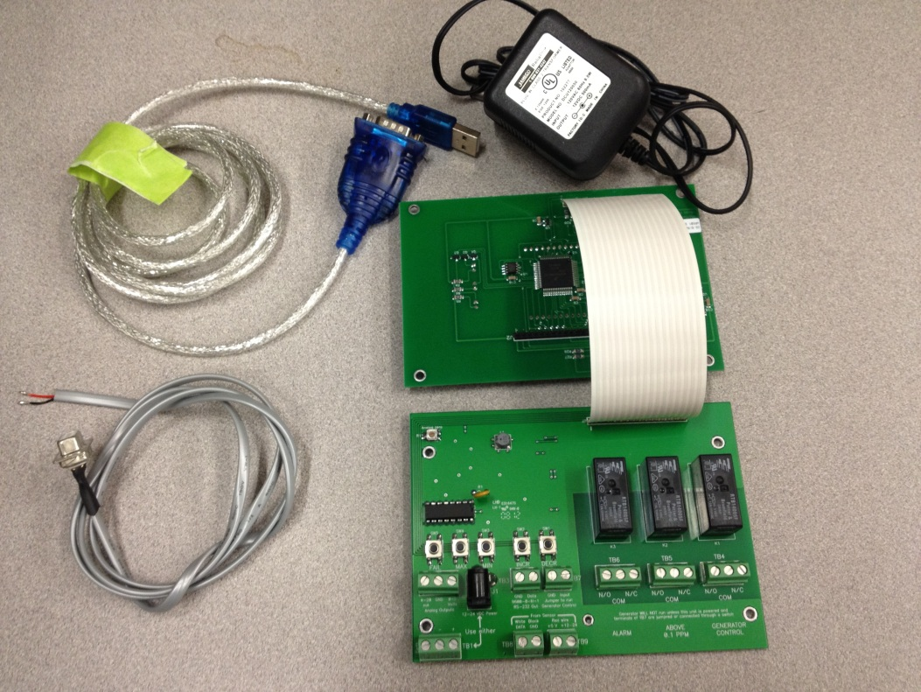
Power Supply
OS-6 board
OS-6 data cable
USB to Serial cable
Figure 1. Components
Data Collection Procedure
- Connect power supply to OS-6, plug power in
- Connect ground and data wire from data cable to TB3 connector on OS-6. Ground is black wire and data is red wire (shown in Figure 2)
- Connect the female DB9 connector on data cable to USB-to-Serial cable
- Connect USB cable to PC
- Install Hyperterminal (htpe63.exe)
- Once installed, open Hyperterminal and type in any name (ex: OS-6)
- Connect to the COM port which the USB-to-Serial cable is plugged into (shown in figure 3)
- Select “restore defaults” (9600, 8, none, 1, off) for COM settings and press “OK”.
(Shown in figure 4)
- Output data should be displayed on screen (shown in figure 5)

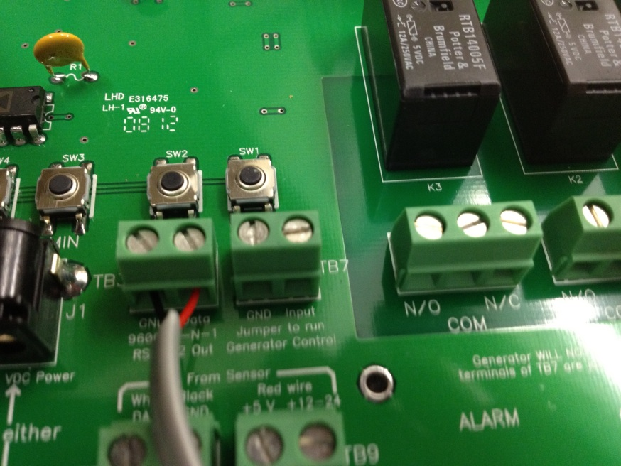
Figure 2. Data and ground wires connected to TB3 on OS-6
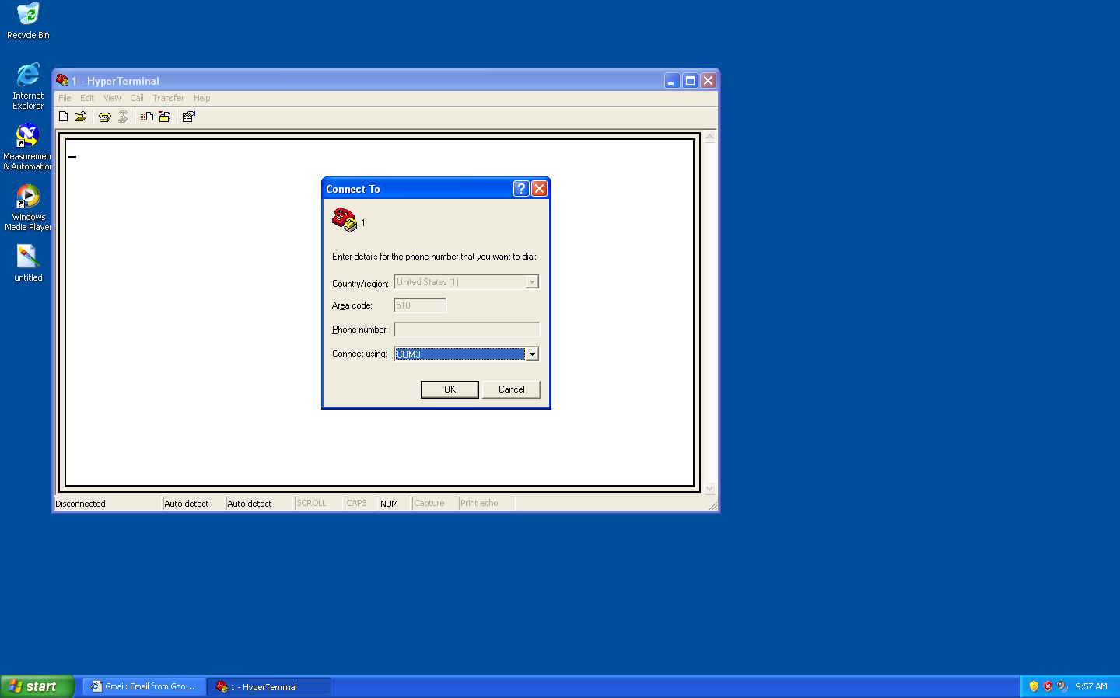
Figure 3. Configuration of COM port

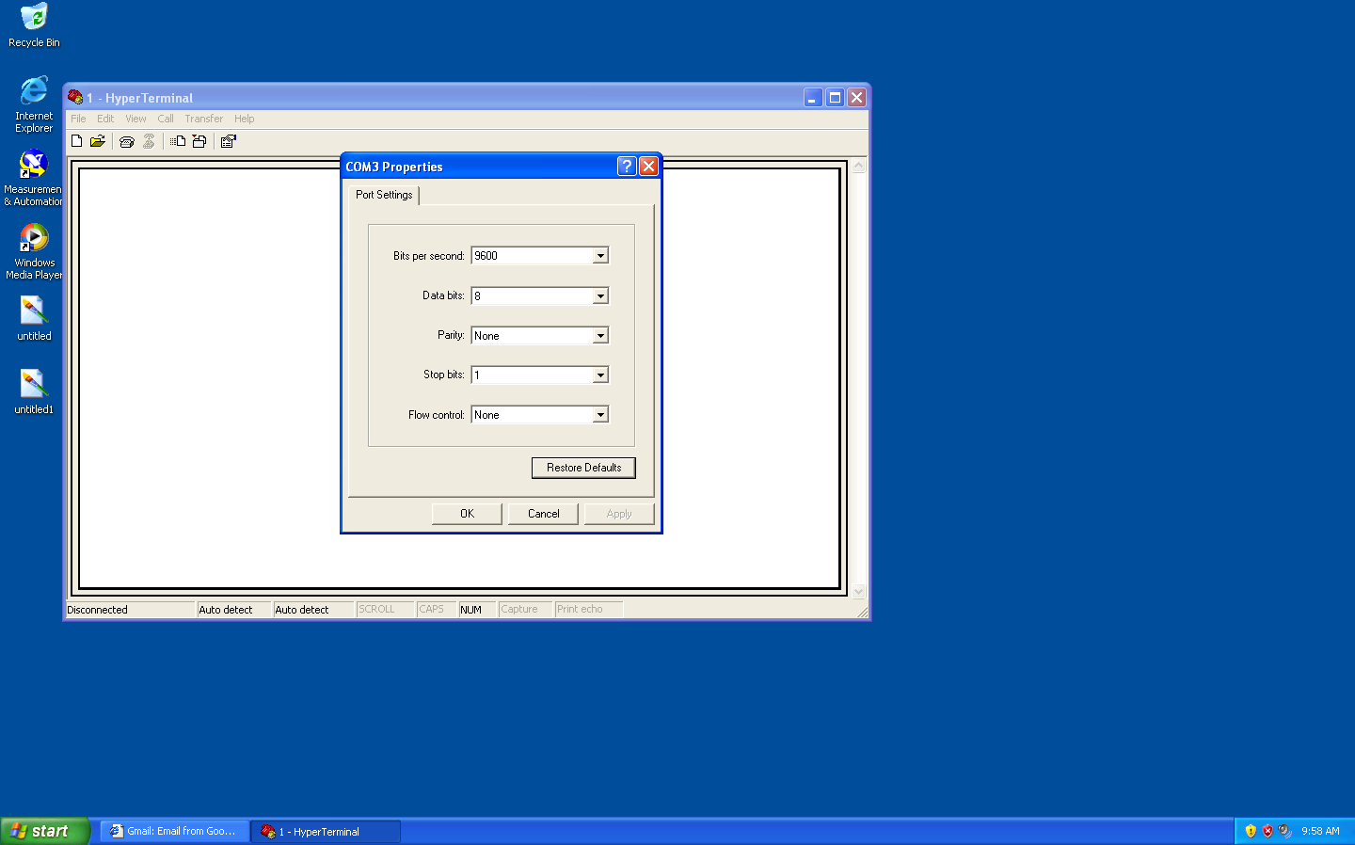
Figure 4. Configuration of COM port settings
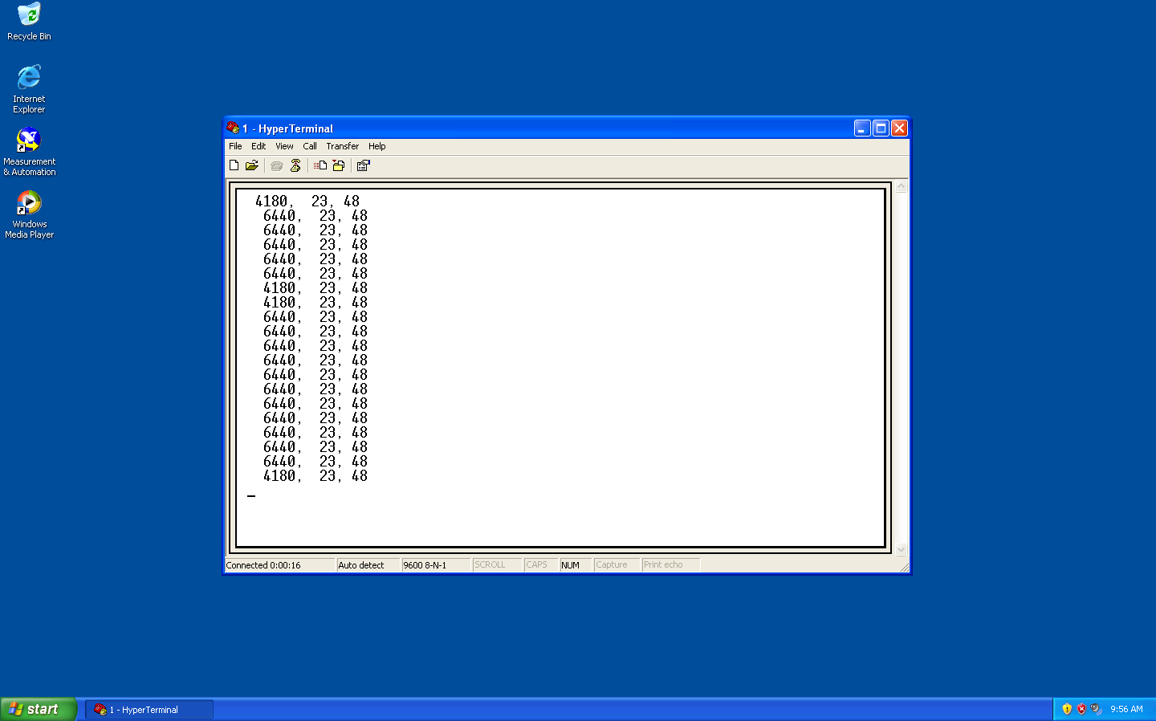
Figure 5. Display of output data

